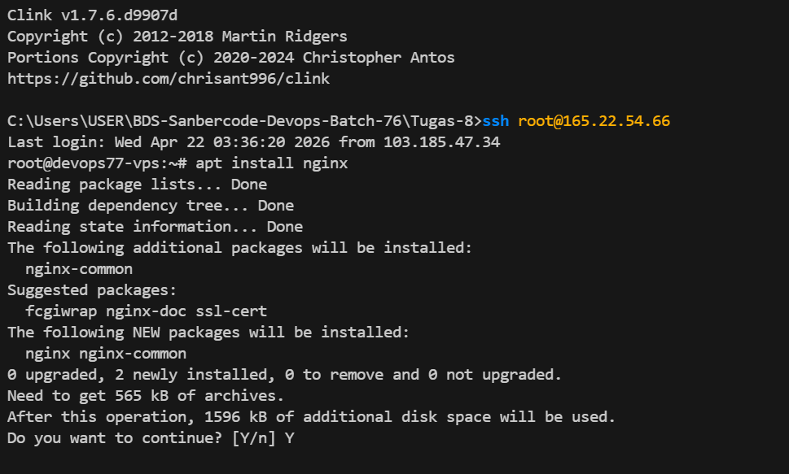

C:\Users\USER\BDS-Sanbercode-Devops-Batch-76\Tugas-8>ssh root@165.22.54.66
Last login: Wed Apr 22 03:36:20 2026 from 103.185.47.34
root@devops77-vps:~# apt install nginx
Reading package lists... Done
Building dependency tree... Done
Reading state information... Done
The following additional packages will be installed:
nginx-common
Suggested packages:
fcgiwrap nginx-doc ssl-cert
The following NEW packages will be installed:
nginx nginx-common
0 upgraded, 2 newly installed, 0 to remove and 0 not upgraded.
Need to get 565 kB of archives.
After this operation, 1596 kB of additional disk space will be used.
Do you want to continue? [Y/n] Y

Get:1 http://mirrors.digitalocean.com/ubuntu noble-updates/main amd64 nginx-common all 1.24.0-2ubuntu7.6 [43.5 kB]
Get:2 http://mirrors.digitalocean.com/ubuntu noble-updates/main amd64 nginx amd64 1.24.0-2ubuntu7.6 [521 kB]
Fetched 565 kB in 6s (91.3 kB/s)
Preconfiguring packages ...
Selecting previously unselected package nginx-common.
(Reading database ... 106665 files and directories currently installed.)
Preparing to unpack .../nginx-common_1.24.0-2ubuntu7.6_all.deb ...
Unpacking nginx-common (1.24.0-2ubuntu7.6) ...
Selecting previously unselected package nginx.
Preparing to unpack .../nginx_1.24.0-2ubuntu7.6_amd64.deb ...
Unpacking nginx (1.24.0-2ubuntu7.6) ...
Setting up nginx-common (1.24.0-2ubuntu7.6) ...
Created symlink /etc/systemd/system/multi-user.target.wants/nginx.service → /usr/lib/systemd/system/nginx.service.
Setting up nginx (1.24.0-2ubuntu7.6) ...
* Upgrading binary nginx [ OK ]
Processing triggers for man-db (2.12.0-4build2) ...
Processing triggers for ufw (0.36.2-6) ...
Scanning processes...
Scanning candidates...
Scanning linux images...

Pending kernel upgrade!
Running kernel version:
6.8.0-71-generic
Diagnostics:
The currently running kernel version is not the expected kernel version 6.8.0-110-generic.

Restarting the system to load the new kernel will not be handled automatically, so you should consider rebooting.

Restarting services...

Service restarts being deferred:
/etc/needrestart/restart.d/dbus.service
systemctl restart getty@tty1.service
systemctl restart serial-getty@ttyS0.service
systemctl restart systemd-logind.service
systemctl restart unattended-upgrades.service

No containers need to be restarted.

No user sessions are running outdated binaries.

No VM guests are running outdated hypervisor (qemu) binaries on this host.

